

Relationship and Sex Education Policy
Prepared by | Gloria Gold, Deputy Headteacher – Pastoral
Acknowledgements | Kenan Drugzani – Head of School, LDE UTC
Date Approved | 6 November 2025
Policy Approved by | Personal Development & Community Committee
Version | 4.0
Next Policy Review Date | November 2027

Version Control Table
Version | Date | Amended by | Rationale
0.1 | 20/04/2020 | Gloria Gold | First draft for consultation with parents.
0.2 | 02/09/2020 | Gloria Gold | Revised first draft following consultation with parents
1.0 | 24/09/2020 |  | Version approved by the Board of Directors
1.1 | 19/08/2021 | Gloria Gold | Annual review of policy – no changes made
2.0 | 23/09/2021 |  | Version approved by the Board
2.1 | 09/11/2023 | Kenan Drugzani | Minor changes to the policy, including changing the policy approval cycle to every two years.  Most changes are to resources used, which are set out in Appendix 1.
3.0 | 16/11/2023 |  | Version approved by the Committee
3.1 | 30/10/2025 | Gloria Gold | Extensive changes have been made in light of new government guidance to come into effect in September 2026
4.0 | 06/11/2025 |  | Version approved by the Committee

Guidance on Version Control:
The above is an example of how to complete the Version control table.
Versions are 0.1, 0.2, etc, until such point as the document is approved. Then it becomes version 1.0.
Subsequent edited versions become 1.1, 1.2, or, if it’s a major update, 2.0. Do not worry about the numbers going up and up; it is about getting the policy right – it’s all fine.

RELATIONSHIP & SEX EDUCATION POLICY

Policy Coverage
THE POLICY APPLIES TO OR COVERS THE FOLLOWING GROUPS
Type of Learner | Tick (✓) | Type of Stakeholder | Tick (✓)
Key Stage 3 (KS3) Carousel | ✓ | Teaching Staff | ✓
Key Stage 4 (KS4) GCSE | ✓ | Education Support Staff | ✓
Key Stage 5 (KS5) Level 2 | ✓ | Administrative Support Staff
Key Stage 5 (KS5) Level 3 | ✓ | Directors | ✓
Key Stage 5 (KS5) A Levels | ✓ | Employers
Apprentices |  | Visitors / Contractors

Contents
1. Policy Aims 3
2. Statutory Requirements 3
3. Policy Development 3
4. Definition 3
5. Curriculum 4
6. Delivery of RSE 4
7. Use of external organisations and materials 6
8. Roles and responsibilities 7
8. Parents’ right to withdraw 8
10. Training 8
11. Monitoring arrangements 8
Appendix 1: Curriculum Map 9
Appendix 2: By the end of secondary school, learners should know 16
Appendix 3: Parent/carer form requesting their child’s withdrawal from sex education within RSE 22

1. Policy Aims
The aims of this Relationships and Sex Education (RSE) Policy at our College are to:
- Provide a framework in which sensitive discussions can take place
- Prepare learners for adulthood, and give them an understanding of sexual development and the importance of health and hygiene
- Help learners develop feelings of self-respect, confidence and empathy and cultivate positive characteristics such as kindness and integrity

- Create a positive culture around issues of sexuality and relationships
- Teach learners the correct vocabulary to describe themselves and their bodies

2. Statutory Requirements
As a secondary academy, we must provide RSE to all learners as per section 34 of the Children and Social work act 2017.
In teaching RSE, we are required by our funding agreements to have regard to guidance issued by the Secretary of State as outlined in section 403 of the Education Act 1996.
We also have regard to legal duties set out in:
- Sections 404 to 407 of the Education Act 1996
- Part 6, chapter 1 of the Equality Act 2010
- The Public Sector Equality Duty (PSED) (as set out in section 149 of the Equality Act 2010). This duty requires public bodies to have due regard to the need to eliminate discrimination, advance equality of opportunity and foster good relations between different people when carrying out their activities

At the London Design and Engineering (LDE) UTC (including LDE UT6), we teach RSE as set out in this policy.

3. Policy Development
This policy has been developed in consultation with staff, learners and parents. The consultation and policy development process involved the following steps:
- Review – a member of staff or working group pulled together all relevant information, including relevant national and local guidance

- Staff consultation – all college staff were given the opportunity to look at the policy and make recommendations

- Parent/stakeholder consultation – parents and any interested parties were invited to comment on the policy

- Learner consultation – we investigated what exactly learners want from their RSE

- Ratification – once amendments were made, the policy was shared with governors and ratified

4. Definition
For the purpose of this policy:
RSE is about the emotional, social and cultural development of learners, and involves learning about relationships, sexual health, sexuality, healthy lifestyles, diversity and personal identity.
RSE involves a combination of sharing information and exploring issues and values.
RSE is not about the promotion of sexual activity.

5. Curriculum
Our RSE curriculum is set out as per Appendix 1, but we may need to adapt it as and when necessary.
We have developed the curriculum in consultation with parents, learners and staff, taking into account the age, needs and feelings of learners and taking into account the age, developmental stage, needs (such as cultural and religious needs) and feelings of our learners. If learners ask questions outside the scope of this policy, teachers will respond in an appropriate manner so they are fully informed and don’t seek answers online.

For more information about our curriculum, see our curriculum map in Appendix 1.

6. Delivery of RSE
RSE is taught within the Learning for Life curriculum. Biological aspects of RSE are taught within the science curriculum.
Learners also receive stand-alone sex education sessions delivered by a trained health professional.
RSE focuses on giving young people the information they need to help them develop healthy, nurturing relationships of all kinds, including:
- Families
- Respectful relationships, including friendships
- Online and media
- Being safe
- Intimate and sexual relationships, including sexual health
For more information about our RSE curriculum, see Appendices 1 and 2.
Teachers delivering RSE will make sure that learners understand the importance of equality and respect, and learn about the law relating to the protected characteristics, as set out in the Equality Act 2010, by the end of their secondary education. The curriculum is designed to focus on learners of all gender identities and expressions, and activities will be planned to make sure all are actively involved.
Throughout each year group, we will use appropriate material to assist learning, such as:
- Diagrams
- Videos
- Books
- Games
- Discussions and practical activities
Teachers will make sure that all learners’ views are listened to, and will encourage them to ask questions and engage in discussion. Teachers will answer questions sensitively, honestly and appropriately for the age of the learners.
The programme will be designed to focus on boys as much as girls, and activities will be planned to make sure both are actively involved.
The college will make sure that all teaching and materials are appropriate for the ages and needs of the learners, including any additional needs, such as special educational needs and disabilities (SEND).
It is important for secondary learners to know what the law says about certain topics covered in RSE, particularly in relation to the law and young people. This will help learners identify what is right and wrong, and can provide a foundation of knowledge for deeper discussion. These topics include, but are not limited to:
- Marriage, including forced marriage and civil partnerships
- Consent, including the age of consent
- Domestic abuse, stalking, rape, sexual offences, female genital mutilation (FGM), ‘virginity testing’ and hymenoplasty
- Sexual abuse, harassment and exploitation, including public sexual harassment and harmful sexual behaviour
- Online behaviours including image and information sharing (including sexual imagery, youth-produced sexual imagery and AI-generated sexual imagery and deepfakes). Learners should understand the law about online sexual harassment and online sexual abuse, including grooming and sextortion
- Pornography
- Abortion
- The protected characteristics
- The age of criminal responsibility
For more information about our RSE curriculum, see Appendices 1 and 2.
We may amend our curriculum content to respond to the needs and context of our learners, to discuss issues affecting them in an age-appropriate manner. We will inform parents and carers of any deviation from our published policy in advance, and share any relevant materials on request.
These areas of learning are taught within the context of family life, taking care to make sure that there is no stigmatisation of children based on their home circumstances (i.e. families can include single-parent families, same-sex parents, families headed by grandparents, adoptive parents and foster parents among other structures), along with reflecting sensitively that some children may have a different structure of support around them (for example, looked-after children, young carers or kinship carers).
Across our college, we will also be mindful of the law and legal requirements, taking care not to condone or encourage illegal activity, such as violent action against people, criminal damage to property or hate crime.
  - Inclusivity
We will teach about these topics in a manner that:
- Considers how a diverse range of learners will relate to them
- Is sensitive to all learners’ experiences
- During lessons, make learners feel:
  - Safe and supported
  - Able to engage with the key messages
We will also:
- Make sure that learners learn about these topics in an environment that’s appropriate for them, for example, in:
  - A whole-class setting
  - Small groups or targeted sessions
  - 1-to-1 discussions
  - Digital formats
- Give careful consideration to the level of differentiation needed

  - Use of resources
We will consider whether any resources we plan to use:
  - Are aligned with the teaching requirements set out in the statutory RSE guidance
  - Would support learners in applying their knowledge in different contexts and settings
  - Are age-appropriate, given the age and maturity of the learners
  - Are evidence-based and contain robust facts and statistics
  - Fit into our curriculum plan
  - Are from credible sources
  - Are compatible with effective teaching approaches
  - Are sensitive to learners’ experiences and won’t provoke distress
We will make sure that when we consult parents/carers, we provide examples of the resources that the college plans to use.

7. Use of external organisations and materials
We will make sure that an agency and any materials used are accurate, age and stage appropriate and unbiased and in line with our legal duties around political impartiality.
We will:
- Make appropriate checks and engage with external agencies to make sure that their approach to teaching about RSE is balanced, and the resources they intend to use:
  - Are age-appropriate
  - Are in line with learners’ developmental stage
  - Comply with:
    - This policy
    - The Teachers’ Standards
    - The Equality Act 2010
    - The Human Rights Act 1998
    - The Education Act 1996
- Only work with external agencies where we have full confidence in the agency, its approach and the resources it uses
- Make sure that any speakers and resources meet the intended outcome of the relevant part of the curriculum
- Review any case-study materials and look for feedback from other people the agency has worked with
- Be clear on:
  - What they’re going to say
  - Their position on the issues to be discussed
- Ask to see in advance any materials that the agency may use
- Know the named individuals who will be there, and follow our usual safeguarding procedures for these people
- Conduct a basic online search and address anything that may be of concern to us, or to parents and carers
- Check the agency’s protocol for taking pictures or using any personal data they might get from a session
- Remind teachers that they can say “no” or, in extreme cases, stop a session
- Make sure that the teacher is in the room during any sessions with external speakers
- Inform all external organisations that the college is legally obliged to share all content with parents and carers
- Share all external materials with parents and carers

We won’t, under any circumstances:
- Work with external agencies that take or promote extreme political positions
- Use materials produced by such agencies, even if the material itself is not extreme
- Work with agencies that don’t allow their material to be shared with parents and carers

8. Roles and responsibilities
8.1 The Board of Directors
The governing board will hold the Principal to account for the implementation of this policy.
8.2 The Principal
The Principal is responsible for making sure that RSE is taught consistently across the college, for sharing all resources and materials with parents and carers, and for managing requests to withdraw learners from components of RSE (see section 9).
8.3 Staff
Staff are responsible for:
- Delivering RSE in a way that is sensitive, high-quality and appropriate for each year group
- Modelling positive attitudes to RSE
- Monitoring progress
- Responding to the needs of individual learners
- Responding appropriately to learners whose parents wish them to be withdrawn from the non-statutory components of RSE
- Modelling positive behaviour and avoiding language that might perpetuate harmful stereotypes, and being conscious of everyday sexism, misogyny, homophobia and stereotypes
- Reporting any safeguarding concerns or disclosures that learners may make as a result of the subject content to the college’s designated safeguarding lead (DSL), Gloria Gold, Deputy Headteacher – Pastoral

Staff do not have the right to opt out of teaching RSE. Staff who have concerns about teaching RSE are encouraged to discuss this with the Principal.
8.4 Learners
All learners are expected to engage fully in RSE and, when discussing issues related to RSE, treat others with respect and sensitivity.

8. Parents’ right to withdraw
Parents have the right to withdraw their children from the non-statutory components of sex education within RSE up to and until 3 terms before the child turns 16. After this point, if the learner wishes to receive sex education rather than being withdrawn, the college will arrange this.
Requests for withdrawal should be put in writing and addressed to the Deputy Headteacher – Pastoral
A copy of the withdrawal requests will be placed in the learner’s educational record. The Deputy Headteacher will discuss the request with parents and take appropriate action.
Alternative work will be given to learners who are withdrawn from sex education.

10. Training
Staff are trained on the delivery of RSE, and it is included in our continuing professional development calendar.
The Deputy Headteacher and / or Heads of Year will also invite visitors from outside the college, such as school nurses or sexual health professionals, to provide support and training to staff teaching RSE.

11. Monitoring arrangements
The delivery of RSE is monitored by Gloria Gold, Deputy Headteacher, through:
Learning walks, classroom observation, learner feedback.
This policy will be reviewed by Gloria Gold, Deputy Headteacher, annually. The policy will be approved by the Board of Directors or a Committee every two years.

Appendix 1: Curriculum Map
Relationships and sex education curriculum map

Year group | Term | Topic/theme details | Resources
Year 9 | Autumn | Relationships:  Being kind to oneself and others  Anti-Bullying  Mental Health | https://ldeutc.padlet.org/KenanDrugzani/learningforlife  https://www.anti-bullyingalliance.org.uk  https://www.mentalhealth.org.uk  https://www.annafreud.org  LMK – Let Me Know (lmkletmeknow.org)
Year 10 | Autumn | Relationships:  - Being kind to self and others  - Anti-bullying  - Mental Health Awareness | https://ldeutc.padlet.org/KenanDrugzani/learningforlife  https://www.anti-bullyingalliance.org.uk  https://www.mentalhealth.org.uk  https://www.annafreud.org  LMK – Let Me Know (lmkletmeknow.org)
Year 11 | Autumn | Relationships:  - Resilience  - Mental Health Awareness  - Coping with exam stress  - Anti-Bullying | https://ldeutc.padlet.org/KenanDrugzani/learningforlife  https://www.anti-bullyingalliance.org.uk  https://www.mentalhealth.org.uk  https://www.annafreud.org  LMK – Let Me Know (lmkletmeknow.org)
Year 12 | Autumn | Relationships:  - Anti-bullying  - Mental Health Awareness  - Preventing Harmful situations to self and others  - Resilience | https://ldeutc.padlet.org/KenanDrugzani/learningforlife  https://www.anti-bullyingalliance.org.uk  https://www.mentalhealth.org.uk  https://www.annafreud.org
Year 13 | Autumn | Relationships:  - Mental Health Awareness  - Social media effects on relationships | https://ldeutc.padlet.org/KenanDrugzani/learningforlife  https://www.anti-bullyingalliance.org.uk  https://www.mentalhealth.org.uk  https://www.annafreud.org
Year 9 | Spring | Relationships / Sex Education  - Online Safety  - Relationships | https://ldeutc.padlet.org/KenanDrugzani/learningforlife  https://www.nspcc.org.uk/keeping-children-safe/online-safety/  https://nationalonlinesafety.com  https://www.saferinternet.org.uk  https://www.thinkuknow.co.uk  External Speakers  Shine | All East Sexual Health  LMK – Let Me Know (lmkletmeknow.org)
Year 10 | Spring | Relationships / Sex Education  - Online Safety  - Relationships  Science GCSE  - Puberty and Sex Hormones  - Menstruation  - Contraception  - Treating Infertility | External Speakers  Shine | All East Sexual Health  LMK – Let Me Know (lmkletmeknow.org)  https://ldeutc.padlet.org/KenanDrugzani/learningforlife  https://www.nspcc.org.uk/keeping-children-safe/online-safety/  https://nationalonlinesafety.com  https://www.saferinternet.org.uk  https://www.thinkuknow.co.uk  LDE UTC Science Curriculum - B5 - Homeostasis and Response  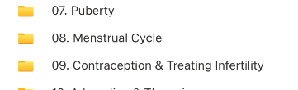
Year 11 | Spring | Relationships / Sex Education  - Online safety  - Digital Footprint  - Contraception | External Speakers  Shine | All East Sexual Health  LMK – Let Me Know (lmkletmeknow.org)  https://ldeutc.padlet.org/KenanDrugzani/learningforlife  https://www.nspcc.org.uk/keeping-children-safe/online-safety/  https://nationalonlinesafety.com  https://www.saferinternet.org.uk  https://www.thinkuknow.co.uk  LDE UTC Science Curriculum - B5 - Homeostasis and Response  See screenshot of the lessons where we teach contraception in Science.
Year 12 | Spring | Relationships / Sex Education  - Sexual Health - STIs  - Sexual consent  - Risky Sexual Behaviour  - Contraception  - Mindfulness  Biology A Level only  - Genetics, evolution and ecosystem  - Patterns of inheritance and variation | External Speakers  Shine | All East Sexual Health  https://ldeutc.padlet.org/KenanDrugzani/learningforlife  https://www.nspcc.org.uk/keeping-children-safe/online-safety/  https://nationalonlinesafety.com  https://www.saferinternet.org.uk  https://www.thinkuknow.co.uk  LDE UTC Science KS5 Curriculum- 6.Genetics,evolution and ecosystem  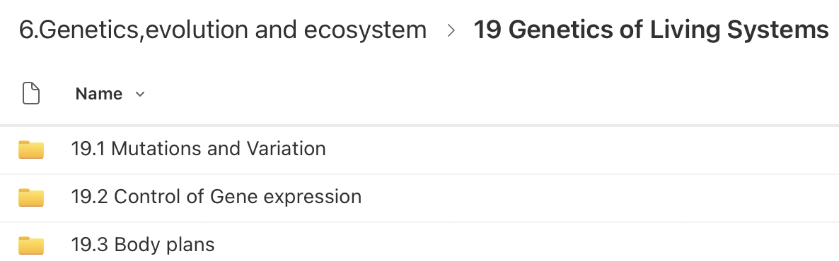
Year 13 | Spring | Relationships / Sex Education  - Consent  - Risky Sexual Behaviour | External Speakers  Shine | All East Sexual Health  LMK – Let Me Know (lmkletmeknow.org)  https://ldeutc.padlet.org/KenanDrugzani/learningforlife  https://www.nspcc.org.uk/keeping-children-safe/online-safety/  https://nationalonlinesafety.com  https://www.saferinternet.org.uk  https://www.thinkuknow.co.uk
Year 9 | Summer | Relationships  - LGBTQ+  - Valuing others and self | https://ldeutc.padlet.org/KenanDrugzani/learningforlife
Year 10 | Summer | Science GCSE  - Hormones in Human Reproduction and Contraception  - Hormones and Infertility  - Sexual and Asexual Reproduction  - Inheritance, variation and evolution – sex determination  - Theory of evolution  Relationships  - LGBTQ+  - Valuing others and self | LDE UTC Science Curriculum - B5 - Homeostasis and Response  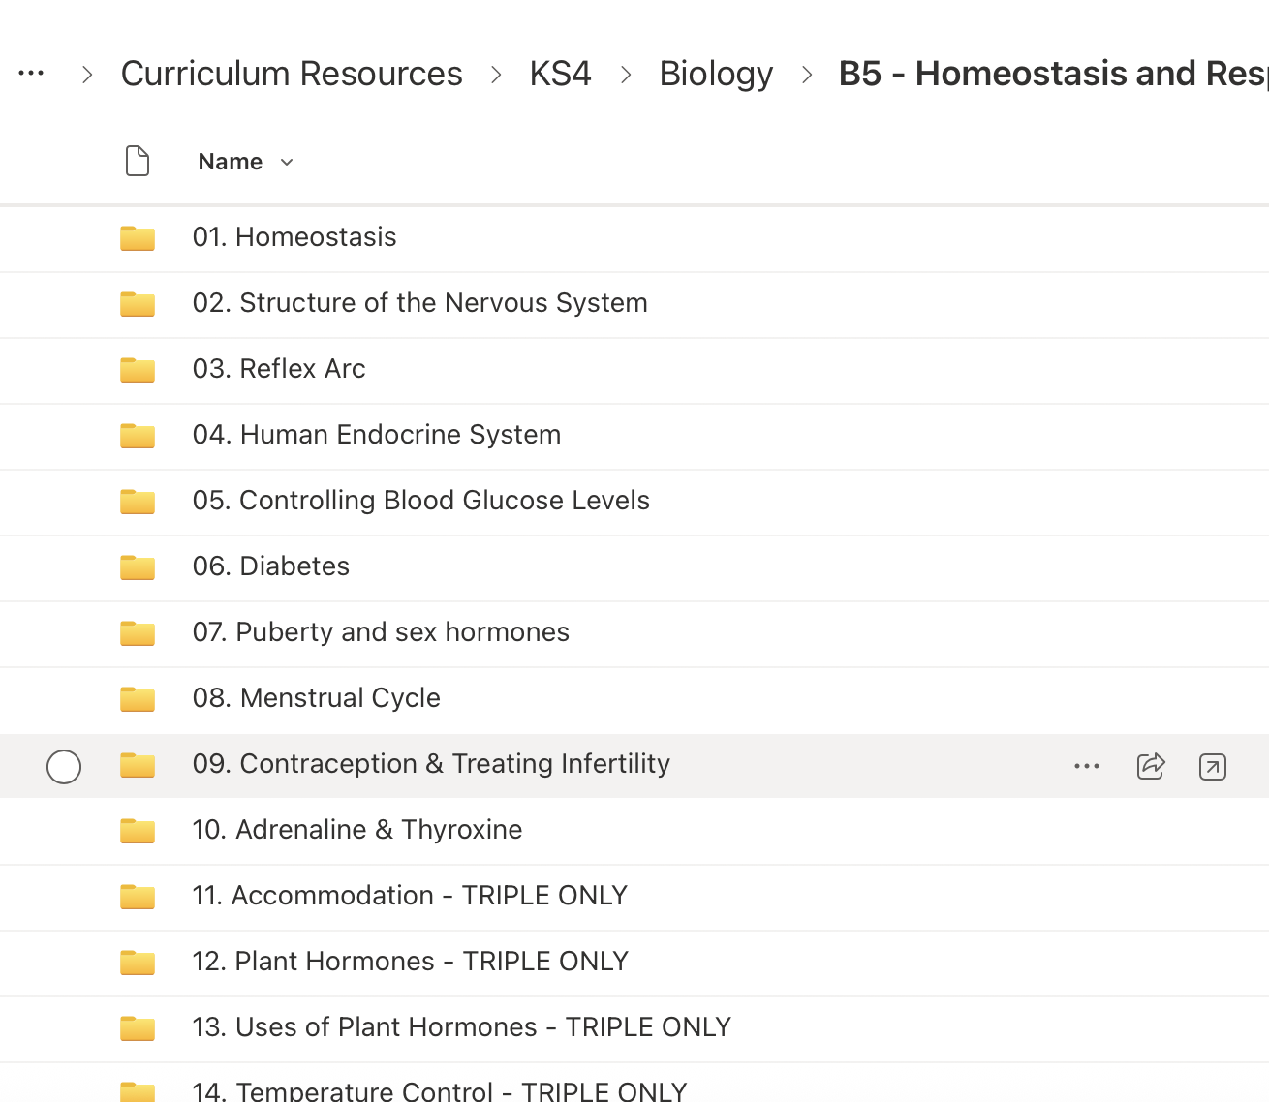  LDE UTC Science Curriculum – B6 - Inheritance, Variation and Evolution  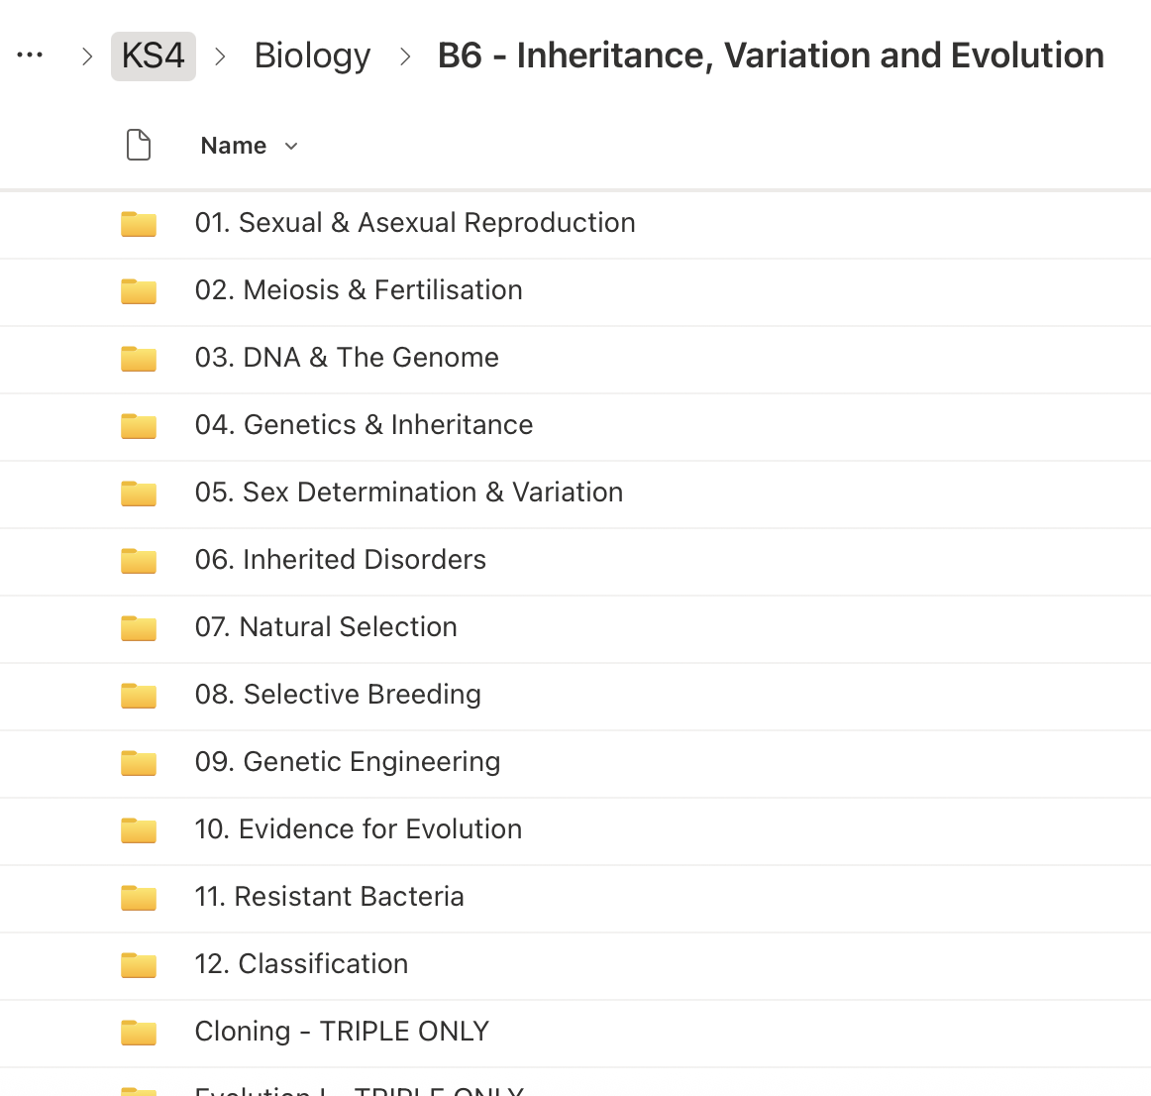  https://ldeutc.padlet.org/KenanDrugzani/learningforlife
Year 12 | Summer | Relationships  - Preparation for Post 18  - LGBTQ+  - Valuing others and self  - Living without harm | https://ldeutc.padlet.org/KenanDrugzani/learningforlife

Appendix 2: By the end of secondary school, learners should know
Topic | LEARNERS should know
Families | - That there are different types of committed, stable relationships  - How these relationships might contribute to wellbeing, and their importance for bringing up children  - Why marriage or civil partnership is an important relationship choice for many couples. The legal status of marriage and civil partnership, including that they carry legal rights, benefits and protections that are not available to couples who are cohabiting or who have, for example, undergone a non-legally binding religious ceremony  - That ‘common-law marriage’ is a myth, and cohabitants do not obtain marriage-like status or rights from living together or by having children  - That forced marriage and marriage before the age of 18 are illegal  - How families and relationships change over time, including through birth, death, separation and new relationships.  - The roles and responsibilities of parents with respect to raising children, including the characteristics of successful parenting and the importance of the early years of a child’s life for brain development.  - How to judge when a relationship is unsafe and where to seek help when needed, including when learners are concerned about violence, harm, or when they are unsure who to trust
Respectful relationships, including friendships | - About the characteristics of positive relationships of all kinds, online and offline, including romantic relationships. For example, learners should understand the role of consent, trust, mutual respect, honesty, kindness, loyalty, shared interests and outlooks, generosity, boundaries, tolerance, privacy, and the management of conflict, reconciliation and ending relationships  - How to evaluate their impact on other people and treat others with kindness and respect, including in public spaces and including strangers. Learners should understand the legal rights and responsibilities regarding equality, and that everyone is unique and equal  - The importance of self-esteem, independence and having a positive relationship with oneself, and how these characteristics support healthy relationships with others. This includes developing one’s own interests, hobbies, friendship groups, and skills. Learners should understand what it means to be treated with respect by others  - What tolerance requires, including the importance of tolerance of other people’s beliefs  - The practical steps learners can take and skills they can develop to support respectful and kind relationships. This includes skills for communicating respectfully within relationships and with strangers, including in situations of conflict  - The different types of bullying (including online bullying), the impact of bullying, the responsibilities of bystanders to report bullying and how and where to get help  - Skills for ending relationships or friendships with kindness and managing the difficult feelings that endings might bring, including disappointment, hurt or frustration  - The role of consent, including in romantic and sexual relationships. Learners should understand that ethical behaviour goes beyond consent and involves kindness, care and attention to the needs and vulnerabilities of the other person, as well as an awareness of power dynamics. Learners should understand that just because someone says ‘yes’ to doing something, that doesn’t automatically make it ethically okay  - How stereotypes, in particular stereotypes based on sex, gender, gender reassignment, race, religion, sexual orientation or disability, can cause damage (e.g. how they might normalise non-consensual behaviour or encourage prejudice). Learners should be equipped to recognise misogyny and other forms of prejudice  - How inequalities of power can impact behaviour within relationships, including sexual relationships. For example, how people who are disempowered can feel they are not entitled to be treated with respect by others or how those who enjoy an unequal amount of power might, with or without realising it, impose their preferences on others  - How pornography can negatively influence sexual attitudes and behaviours, including by normalising harmful sexual behaviours and by disempowering some people, especially women, to feel a sense of autonomy over their own body and providing some people with a sense of sexual entitlement to the bodies of others  - How some subcultures might influence our understanding of sexual ethics, including the sexual norms endorsed by so-called ‘involuntary celibates’ (incels) or online influencers
Online safety and awareness | - Their rights, responsibilities and opportunities online, including that the same expectations of behaviour apply in all contexts, including online  - About online risks, including that any material they provide to another has the potential to be shared and circulated online and the difficulty of removing potentially compromising material placed online. They should also understand the difference between public and private online spaces and related safety issues  - Not to provide material to others that they would not want to be distributed further, and not to pass on personal material which is sent to them. Learners should understand that any material provided online might be circulated, and that once this has happened, there is no way of controlling where it ends up. Learners should understand the serious risks of sending material to others, including the law concerning the sharing of images  - About the characteristics of social media, including that some social media accounts are fake, and/or may post things which aren’t real or have been created with AI. They should also know that social media users may say things in more extreme ways than they might in face-to-face situations, and that some users present highly exaggerated or idealised profiles of themselves online  - That keeping or forwarding indecent or sexual images of someone under 18 is a crime (even if the photo is of themselves or someone who has consented, and even if the photo was created by that child and/or using AI). There are potentially serious consequences of acquiring or generating these images. That sharing indecent images of people over 18 without their consent is also a crime  - How to seek support. They should also understand that they will not be in trouble for asking for help, either at school or with the police, if an image of themselves has been shared  - What to do and how to report when they are concerned about material that has been circulated, including personal information, images or videos, and how to manage issues online  - About the prevalence of deepfakes, including videos and photos, how deepfakes can be used maliciously as well as for entertainment, the harms that can be caused by deepfakes and how to identify them  - That the internet contains inappropriate and upsetting content, some of which is illegal, including unacceptable content that encourages misogyny, violence or the use of weapons  - Where to go for advice and support about something they have seen online. Learners should understand that online content can present a distorted picture of the world and normalise or glamourise behaviours which are unhealthy and wrong  - That social media can lead to escalations in conflicts, how to avoid these escalations and where to go for help and advice  - How to identify when technology and social media are used as part of bullying, harassment, stalking, coercive and controlling behaviour, and other forms of abusive and/or illegal behaviour and how to seek support about concerns  - That pornography, and other online content, often presents a distorted picture of people and their sexual behaviours and can negatively affect how people behave towards sexual partners. This can affect people who see pornographic content accidentally, as well as those who see it deliberately. That pornography can also portray misogynistic behaviours and attitudes, which can negatively influence those who see it  - How information and data is generated, collected, shared and used online  - That websites may share personal data about their users, and information collected on their internet use, for commercial purposes (for example, to enable targeted advertising)  - That criminals can operate online scams, such as using fake websites or emails to extort money or valuable personal information. This information can be used to the detriment of the person or wider society. About risks of sextortion, how to identify online scams relating to sex, and how to seek support if they have been scammed or involved in sextortion  - That AI chatbots are an example of how AI is rapidly developing, and that these can pose risks by creating fake intimacy or offering harmful advice. That it is important to be able to critically think about new types of technology as they appear online and how they might pose a risk
Being safe | - How to recognise, respect and communicate consent and boundaries in relationships, including in early romantic relationships (in all contexts, including online) and early sexual relationships that might involve kissing or touching. That kindness and care for others require more than just consent  - That there is a range of strategies for identifying, resisting and understanding pressure in relationships from peers or others, including sexual pressure, and how to avoid putting pressure on others  - How to determine whether other children, adults or sources of information are trustworthy, how to judge when a relationship is unsafe (and recognise this in the relationships of others); how to seek help or advice, including reporting concerns about others if needed  - How to increase their personal safety in public spaces, including when socialising with friends, family, the wider community or strangers. About ways of seeking help when needed and how to report harmful behaviour. That there are strategies they can use to increase their safety, and that this does not mean they will be blamed if they are victims of harmful behaviour. About the importance of trusting their instincts when something doesn’t feel right, and they should understand that in some situations, a person might appear trustworthy but have harmful intentions  - What constitutes sexual harassment or sexual violence, and that such behaviour is unacceptable, emphasising that it is never the fault of the person experiencing it  - That sexual harassment includes unsolicited sexual language, attention or touching, taking and/or sharing intimate or sexual images without consent, public sexual harassment, pressuring other people to do sexual things, and upskirting  - About concepts and laws relating to:  - Sexual violence, including rape and sexual assault  - Harmful sexual behaviour, which includes all types of sexual harassment and sexual violence among young people, but also includes other forms of concerning behaviour like using age-inappropriate sexual language  - Domestic abuse, including controlling or coercive behaviour, emotional, sexual, economic or physical abuse, and violent or threatening behaviour  - Harms which are exploitative, including sexual exploitation, criminal exploitation and abuse, grooming, and financial exploitation  - Forced marriage  - Female genital mutilation (FGM), virginity testing and hymenoplasty  - That fixated, obsessive, unwanted and repeated behaviours can be criminal, and where to get help if needed  - That strangulation and suffocation are criminal offences, and that strangulation (applying pressure to the neck) is an offence, regardless of whether it causes injury  - That any activity that involves applying force or pressure to someone’s neck or covering someone’s mouth and nose is dangerous and can lead to serious injury or death  - That pornography presents some activities as normal, which many people do not and will never engage in, some of which can be emotionally and/or physically harmful  - How to seek support for their own worrying or abusive behaviour, or for worrying or abusive behaviour they have experienced from others, including information on where to report abuse and where to seek medical attention when required, for example, after an assault
Intimate and sexual relationships, including sexual health | - That sex, for people who feel ready and are over the age of consent, can and should be enjoyable and positive  - The law about the age of consent, that they have a choice about whether to have sex, that many young people wait until they are older, and that people of all ages can enjoy intimate and romantic relationships without sex  - About sexual consent and their capacity to give, withhold or remove consent at any time, even if initially given, as well as the considerations that people might take into account prior to sexual activity, such as the law, their faith and family values. That kindness and care for others require more than just consent  - That all aspects of health can be affected by choices they make in sex and relationships, positively or negatively, e.g. physical, emotional, mental, sexual and reproductive health and wellbeing  - That some sexual behaviours can be harmful  - The facts about the full range of contraceptive choices, efficacy and options available, including male and female condoms, and signposting towards medically accurate online information about sexual and reproductive health to support contraceptive decision making  - That there are choices in relation to pregnancy. Learners should be given medically and legally accurate and impartial information on all options, including keeping the baby, adoption, abortion and where to get further help  - How the different sexually transmitted infections (STIs), including HIV/AIDs, are transmitted. How risk can be reduced through safer sex (including through condom use)  - About the use and availability of the HIV prevention drugs pre-exposure prophylaxis (PrEP) and post-exposure prophylaxis (PEP), and how and where to access them. The importance of, and facts about, regular testing and the role of stigma  - About the prevalence of STIs, the short and long-term impact they can have on those who contract them, and key facts about treatment  - How the use of alcohol and drugs can lead people to take risks in their sexual behaviour  - How and where to seek support for concerns around sexual relationships, including sexual violence or harms  - How to counter misinformation, including signposting towards medically accurate information and further advice, and where to access confidential sexual and reproductive health advice and treatment

Appendix 3: Parent/carer form requesting their child’s withdrawal from sex education within RSE
To be completed by parents/CARERS
Name of child |  | Class
Name of parent/carer |  | Date
Reason for withdrawing from sex education within relationships and sex education
Any other information you would like the school to consider
Parent/carer signature

To be completed by the COLLEGE
Agreed actions from discussion with parents/carers | Include notes from discussions with parents/carers and agreed actions taken.  E.g: X Y learner will be taking part in all relationships lessons and during the sex education lessons, he will be working independently on a project in the year 5 classroom

